Barry Hoinacki Jr

CMPSC 206

10/3/18

Web Project Proposal

Section 1:

Purpose of the website as a way to learn how to play the heavy weapons class in the game Team Fortress 2. I want the site to teach players who are interested in the class how to play it in a way that is usually better than just running out and doing whatever. As well as to teach veteran players some possible things about the class, whether it be a technique or a strategy, that they too can learn yet have not known about to help them play the class better. And finally to showcase that this class has a lot more going on than just holding down a spot and just killing players who cross the corner you were guarding. As stated, my target audience is from new players who want to learn a class, players who like heavy and would like to learn more about him on a competitive level, and veterans of the game who want to learn a thing or two about a class they barely play.

The opportunity of this website is to address how in-depth heavy can be, as most of the player base see him as a brainless “hold down the corridor” class and nothing else. While he is effective at that strategy, I want to showcase things that can he can do more while also going in-depth on how there are more subtle things going on with the class, even if you are just “holding down a corridor.” The media I plan to use is either pictures or video to show what I’m talking about: whether it be an item, a spot on the map, or to demonstrate a technique.

Two example URLs would be this page from a wiki dedicated to competitive TF2, http://comp.tf/wiki/Heavy , and a guide on the steam forums , https://steamcommunity.com/sharedfiles/filedetails/?id=165580693. My plan is to try to be more useful and alive without sacrificing any useful information you might need in the learning process of the class.

Section 2: Flowchart.

Home (index.html)

Playstyles (playstyles.html)

Maps (maps.html)

Weapons (weapons.html)

Advanced Tactics (adv_tactics.html)

Product (map_product.html)

Lakeside (map_lakeside.html)

 Borneo (map_borneo.html)

Upward (map_upward.html)

Gullywash (map_gullywash.html)

Section 3: Wireframe.

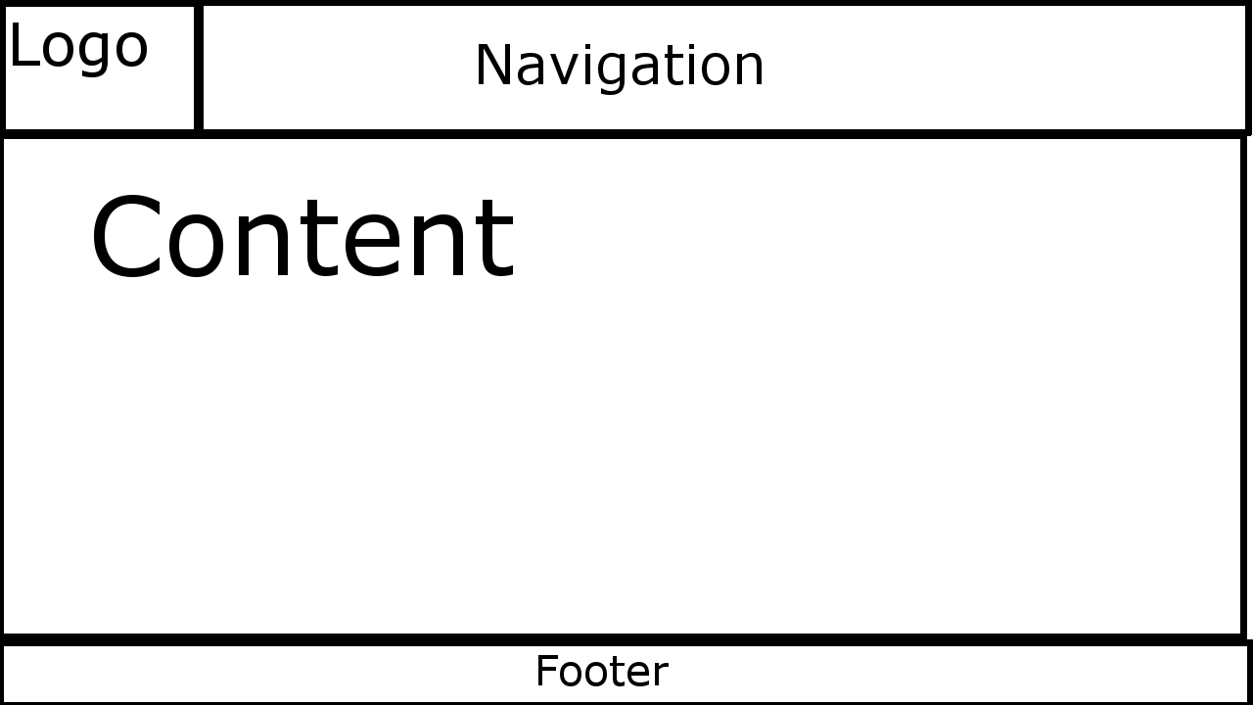

Using the font family of Verdana, Arial, and san-serif for all of them. Color schemes will be using mostly grays and light to semi-dark browns. Headings will be bold and try to start up topics and use the paragraphs to describe them. Use unordered lists if need be. The header area will contain the logo (which is an anchor for the main home page) and various other navigations. Footer area will use italic text and link to email.